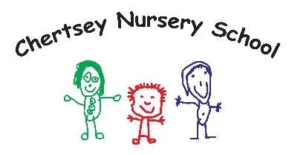

www.chertsey.surrey.sch.uk
Pyrcroft Road, Chertsey, Surrey. KT16 9ER
01932 562225
info@chertsey.surrey.sch.uk
Executive Headteacher – Donna Harwood-Duffy Head of School – Anita Cheeseman

April 2023

Dear Applicant

Re: Nursery Assistant
Thank you for your interest in our vacancy for Nursery Assistant in our school. I enclose an application pack for candidates, which contains information about our School, the positions available for Nursery Assistant posts, as well as an Application Form.

Role – 20 hours a week. Mon to Fri 11.15pm – 3.15pm

I hope you will be able to take advantage of the opportunity to visit our website www.chertsey.surrey.sch.uk/job-vacancies over the next couple of weeks, and if you would like to visit prior to submitting an application or like additional information, then please email me on head@chertsey.surrey.sch.uk.

Please complete the application form fully, ensuring you specify which role you are applying for, as well as addressing the items on the Job Profile in your supporting statement. Please also check that you have given details of your referees, one of whom should be your current or most recent employer, and another should be someone who is able to comment on your performance at work from a position of responsibility, not as a peer. Please be aware that if you are offered an interview, we will take up references at this stage. Note that CVs will not be accepted as applications.
Salary is based on Surrey’s payscale, S1/2, £19,233 FTE pro rata,

The closing date for receipt of completed applications is 12 noon on Friday 19th May 2023 and interviews will be held week beginning Monday 22nd May 2023. We will be contacting candidates as soon as possible after shortlisting.

Please return completed applications to Lisa Harding office@chertsey.surrey.sch.uk . Thank you very much for your interest. I wish you success with your application.

Yours sincerely
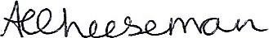

Anita Cheeseman
Head of School

Chertsey Nursery School is committed to safeguarding and promoting the welfare of children, young people families and carers and expects all staff and volunteers to share this commitment. Appointment to this post will be subject to an enhanced background checks by the Disclosure and Baring Service and satisfactory references.

